AI IN AUTONOMOUS VEHICLES
21CSC205P Database Management Systems
A MINI PROJECT REPORT

Submitted by
KANUMURI LALITH SHREEKAR[RA2411003012051]
SRIJAI KUBENDIRAN[RA2411003012049]

Under the Guidance of

(DR. R.K.PONGIANNAN )
(Professor, Department of Computing Technologies)

in partial fulfillment of the requirements for the degree of

BACHELOR OF TECHNOLOGY

in

COMPUTER SCIENCE ENGINEERING

with specialization in (CORE)


DEPARTMENT OF NETWROKING AND COMMUNICATIONS

SCHOOL OF COMPUTING

COLLEGE OF ENGINEERING AND TECHNOLOGY
SRM INSTITUTE OF SCIENCE AND TECHNOLOGY

KATTANKULATHUR- 603 203
MAY 2026


SRM INSTITUTE OF SCIENCE AND TECHNOLOGY KATTANKULATHUR – 603 203

BONAFIDE CERTIFICATE

Certified that Project report titled “AI IN AUTONOMOUS VEHICLES ” is the bonafide work of “KANUMURI LALITH SHREEKAR [RA2411003012051], SRIJAI KUBENDIRAN[RA2411003012049]” who carried out the 21CSC205P Database Management Systems mini project work under my supervision.

COURSE FACULTY | HEAD OF THE DEPARMENT
DESIGNATION  Department | PROFESSOR AND HEAD  Department

ABSTRACT

TABLE OF CONTENTS

Chapter No. | Title | Page no.
 | ABSTRACT
1 | Problem understanding, Identification of Entity and Relationships, Construction of DB using ER Model for their project
2 | Design of Relational Schemas, Creation of Database and Tables for their project
3 | 3.1Writing queries based on the concepts of Aggregate functions, constraints, sets
 | 3.2 Writing complex queries based on subqueries, joins and views
 | 3.3 Writing complex queries based on the concepts of functions, Triggers, Cursors and Exception Handling
4 | 4.1 Analysing the pitfalls, identifying the dependencies, and applying Normalizations- 1NF, 2NF, 3NF
 | 4.2 Analysing the pitfalls, identifying the dependencies, and applying Normalizations- 4NF, 5NF
5 | Implementation of concurrency control and recovery mechanisms.
6 | Front-end And Back-End Implementation code
7 | Results and Discussions

LIST OF FIGURES

Figure No. | Name | Page no.
1
2
3
4
5

LIST OF TABLES

Figure No. | Name | Page no.
1
2
3
4
5

CHAPTER 1

PROBLEM UNDERSTANDING, IDENTIFICATION OF ENTITY AND RELATIONSHIPS, CONSTRUCTION OF DB USING ER MODEL FOR THE <PROJECT Name>

  - Introduction
The advancement of Autonomous Vehicles (AVs) has transformed modern transportation by integrating Artificial Intelligence (AI), machine learning, and real-time sensor processing. Autonomous vehicles rely on a combination of cameras, LiDAR, radar, GPS, and AI models to perceive their environment and make driving decisions without human intervention.
However, the large-scale deployment of autonomous vehicles introduces a significant data management challenge. Each vehicle generates enormous volumes of structured and unstructured data during every trip, including sensor readings, AI perception outputs, trip logs, and safety incidents. Managing this data efficiently is crucial for performance evaluation, safety assurance, and continuous improvement of AI models.
AI in Autonomous Vehicles Management System is a database-driven solution designed to organize, store, and analyze operational data generated by autonomous vehicle fleets. The system uses Database Management System (DBMS) principles to provide a structured, reliable, and query-efficient platform for tracking vehicles, sensors, AI models, trips, and incidents.

  - Motivation
The motivation for developing the AV-Insight system arises from the following challenges:
- Autonomous vehicles generate terabytes of data daily, but only a small portion is critical for safety and AI improvement.
- Traditional logging systems store data in flat files, making analysis complex and time-consuming.
- There is no efficient way to correlate AI model versions with incident severity.
- Safety engineers need fast access to incident history across multiple vehicles and trips.
- Manual analysis of logs increases the risk of missed safety-critical events.
To overcome these challenges, AV-Insight applies relational database concepts such as entity relationships, normalization, constraints, and SQL queries to transform raw data into meaningful insights.
  - Scope
The scope of the AV-Insight project includes the following functionalities:
- Fleet Management
Stores information about autonomous vehicles, including their model, operational status, and associated AI model version.
- AI Model Tracking
Maintains records of AI models deployed in vehicles, including version names and release dates.
- Sensor Management
Tracks different sensors (camera, LiDAR, radar) installed on each vehicle.
- Trip Monitoring
Records trip details such as start time, end time, location, and associated vehicle.
- Incident Management
Stores safety-critical events such as manual overrides and sensor failures, along with severity levels.
The system is designed to support efficient querying, scalability, and data integrity, making it suitable for real-world autonomous vehicle operations.
  - Problem Statement
Managing autonomous vehicle data is a complex task due to the lack of structured relationships between vehicles, AI models, sensors, trips, and incidents. Existing systems often fail to provide a centralized and normalized database, resulting in inefficient querying and poor data consistency.
Without a proper DBMS:
- It is difficult to identify which AI model version causes frequent high-severity incidents.
- Safety engineers cannot easily retrieve all incidents related to a specific vehicle or sensor.
- Data redundancy leads to storage inefficiency and inconsistency.
Problem Statement:
To design and implement a structured database management system that efficiently stores, manages, and retrieves autonomous vehicle operational data, enabling meaningful analysis of AI performance and safety incidents.
  - Project Requirements
Table 1.1: Project Requirements
ID | CATEGORY | DESCRIPTION
$$R_{1}$$ | Functional | Store multiple sensors for each vehicle
$$R_{2}$$ | Functional | Track AI model versions deployed in vehicles
$$R_{3}$$ | Functional | Record trip details with time and location
$$R_{4}$$ | Functional | Capture incidents linked to trips
$$R_{5}$$ | Integrity | Enforce referential integrity using foreign keys
$$R_{6}$$ | Performance | Sup[port complex queries for safety analysis

  - Identification of Entity and Relationships
1.6.1 Entities and Attributes
- AI_Model
- Model_ID (Primary Key)
- Version_Name
- Release_Date
- Vehicle
- Vehicle_ID (Primary Key)
- Make_Model
- Status
- AI_Model_ID (Foreign Key)
- Sensor
- Sensor_ID (Primary Key)
- Type
- Vehicle_ID (Foreign Key)
- Trip
- Trip_ID (Primary Key)
- Start_Time
- End_Time
- Location
- Vehicle_ID (Foreign Key)
- Incident
- Incident_ID (Primary Key)
- Incident_Type
- Severity
- Trip_ID (Foreign Key)
1.6.2 Relationships
- A Vehicle runs one AI Model
- A Vehicle has multiple Sensors
- A Vehicle performs multiple Trips
- A Trip logs multiple Incidents

  - Construction of DB Using ER Model for the <Project name>
The Entity-Relationship (ER) model represents the logical structure of the AV-Insight database. Each entity is uniquely identified using a primary key, and relationships are established using foreign keys to ensure data integrity.
The ER diagram illustrates:
- One-to-many relationships between Vehicle and Sensor
- One-to-many relationships between Vehicle and Trip
- One-to-many relationships between Trip and Incident
- One-to-one relationship between Vehicle and AI_Model
This ER-based design ensures:
- Minimal data redundancy
- High consistency
- Efficient query execution

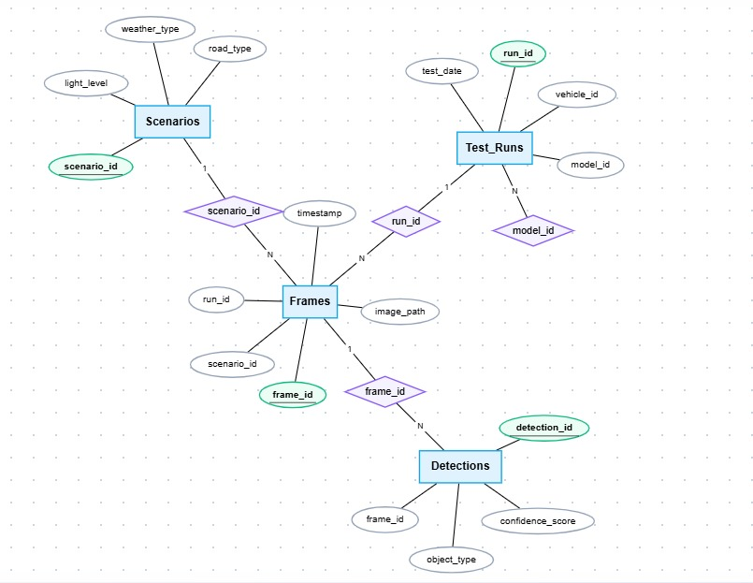

Figure 1.1: ER diagram of AV-Insight Management System

Chapter 2
Design of Relational Schemas, Creation of Database and Tables for AI IN AUTONOMOUS VEHICLES

2.1 Relational Schema for AI IN AUTONOMOUS VEHICLES
Sample
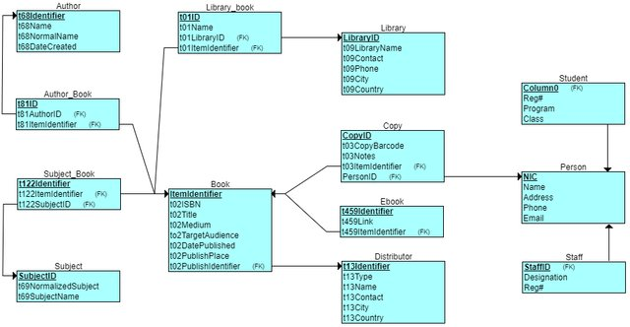
Figure 2.1: Relational Schema for <project title>
The figure 2.1 depicts the relational schema for the <project title> . (give explanation)

2.2 Description of Tables
The current project uses SQLite. SQLite does not enforce fixed column sizes such as VARCHAR(50), so the "Size" column below describes the practical storage nature of each attribute.
Table: AI_Models
Attribute | Data Type | Size | Constraints
model_id | INTEGER | Variable, up to 8 bytes | Primary Key, Auto Increment
version_name | TEXT | Variable length | NOT NULL, UNIQUE
architecture | TEXT | Variable length | NOT NULL
accuracy_score | REAL | 8 bytes floating point | NOT NULL, CHECK (accuracy_score BETWEEN 0.0 AND 1.0)
Table: Scenarios
Attribute | Data Type | Size | Constraints
scenario_id | INTEGER | Variable, up to 8 bytes | Primary Key, Auto Increment
weather_type | TEXT | Variable length | NOT NULL, CHECK (weather_type IN ('Rain', 'Fog', 'Sunny'))
light_level | TEXT | Variable length | NOT NULL, CHECK (light_level IN ('Day', 'Night'))
road_type | TEXT | Variable length | NOT NULL, CHECK (road_type IN ('Highway', 'Urban'))
difficulty | TEXT | Variable length | NOT NULL, CHECK (difficulty IN ('Low', 'Medium', 'High', 'Critical'))
Table: Vehicles
Attribute | Data Type | Size | Constraints
vehicle_id | INTEGER | Variable, up to 8 bytes | Primary Key, Auto Increment
make_model | TEXT | Variable length | NOT NULL
ai_model_id | INTEGER | Variable, up to 8 bytes | NOT NULL, Foreign Key references AI_Models(model_id) ON DELETE RESTRICT
status | TEXT | Variable length | NOT NULL
Table: Test_Runs
Attribute | Data Type | Size | Constraints
run_id | INTEGER | Variable, up to 8 bytes | Primary Key, Auto Increment
vehicle_id | INTEGER | Variable, up to 8 bytes | NOT NULL, Foreign Key references Vehicles(vehicle_id) ON DELETE RESTRICT
scenario_id | INTEGER | Variable, up to 8 bytes | NOT NULL, Foreign Key references Scenarios(scenario_id) ON DELETE RESTRICT
test_date | TEXT | Variable length | NOT NULL
avg_speed | REAL | 8 bytes floating point | NOT NULL, DEFAULT 0
Table: Frames
Attribute | Data Type | Size | Constraints
frame_id | INTEGER | Variable, up to 8 bytes | Primary Key, Auto Increment
run_id | INTEGER | Variable, up to 8 bytes | NOT NULL, Foreign Key references Test_Runs(run_id) ON DELETE CASCADE
timestamp | TEXT | Variable length | NOT NULL
image_path | TEXT | Variable length | NOT NULL
Table: Detections
Attribute | Data Type | Size | Constraints
detection_id | INTEGER | Variable, up to 8 bytes | Primary Key, Auto Increment
frame_id | INTEGER | Variable, up to 8 bytes | NOT NULL, Foreign Key references Frames(frame_id) ON DELETE CASCADE
object_type | TEXT | Variable length | NOT NULL
confidence_score | NUMERIC | Variable numeric storage | NOT NULL, CHECK (confidence_score BETWEEN 0.0 AND 0.999)
Additional schema objects:
- Index idx_test_runs_scenario_id on Test_Runs(scenario_id)
- Index idx_detections_confidence_score on Detections(confidence_score)
2.3 Creation of Database and Tables - DDL Commands
Note: In the current project, the SQLite database file is drivelearn.db. The database and tables are created by the application using the following DDL commands.
PRAGMA foreign_keys = ON;

CREATE TABLE IF NOT EXISTS AI_Models (
model_id INTEGER PRIMARY KEY AUTOINCREMENT,
version_name TEXT NOT NULL UNIQUE,
architecture TEXT NOT NULL,
accuracy_score REAL NOT NULL CHECK (accuracy_score BETWEEN 0.0 AND 1.0)
);

CREATE TABLE IF NOT EXISTS Scenarios (
scenario_id INTEGER PRIMARY KEY AUTOINCREMENT,
weather_type TEXT NOT NULL CHECK (weather_type IN ('Rain', 'Fog', 'Sunny')),
light_level TEXT NOT NULL CHECK (light_level IN ('Day', 'Night')),
road_type TEXT NOT NULL CHECK (road_type IN ('Highway', 'Urban')),
difficulty TEXT NOT NULL CHECK (difficulty IN ('Low', 'Medium', 'High', 'Critical'))
);

CREATE TABLE IF NOT EXISTS Vehicles (
vehicle_id INTEGER PRIMARY KEY AUTOINCREMENT,
make_model TEXT NOT NULL,
ai_model_id INTEGER NOT NULL,
status TEXT NOT NULL,
FOREIGN KEY (ai_model_id) REFERENCES AI_Models(model_id) ON DELETE RESTRICT
);

CREATE TABLE IF NOT EXISTS Test_Runs (
run_id INTEGER PRIMARY KEY AUTOINCREMENT,
vehicle_id INTEGER NOT NULL,
scenario_id INTEGER NOT NULL,
test_date TEXT NOT NULL,
avg_speed REAL NOT NULL DEFAULT 0,
FOREIGN KEY (vehicle_id) REFERENCES Vehicles(vehicle_id) ON DELETE RESTRICT,
FOREIGN KEY (scenario_id) REFERENCES Scenarios(scenario_id) ON DELETE RESTRICT
);

CREATE TABLE IF NOT EXISTS Frames (
frame_id INTEGER PRIMARY KEY AUTOINCREMENT,
run_id INTEGER NOT NULL,
timestamp TEXT NOT NULL,
image_path TEXT NOT NULL,
FOREIGN KEY (run_id) REFERENCES Test_Runs(run_id) ON DELETE CASCADE
);

CREATE TABLE IF NOT EXISTS Detections (
detection_id INTEGER PRIMARY KEY AUTOINCREMENT,
frame_id INTEGER NOT NULL,
object_type TEXT NOT NULL,
confidence_score NUMERIC NOT NULL CHECK (confidence_score BETWEEN 0.0 AND 0.999),
FOREIGN KEY (frame_id) REFERENCES Frames(frame_id) ON DELETE CASCADE
);

CREATE INDEX IF NOT EXISTS idx_test_runs_scenario_id
ON Test_Runs(scenario_id);

CREATE INDEX IF NOT EXISTS idx_detections_confidence_score
ON Detections(confidence_score);
2.4 Insertion of tuples into the table - DML Commands
Note: The current project contains master tables (AI_Models, Scenarios, Vehicles) and transactional tables (Test_Runs, Frames, Detections). The first three are inserted directly, while the larger tables are populated programmatically by the application. The SQL below uses real tuples from the current project database.
Current table sizes on 2026-03-23:
- AI_Models: 3 rows
- Scenarios: 3 rows
- Vehicles: 3 rows
- Test_Runs: 20 rows
- Frames: 200 rows
- Detections: 310 rows
Table: AI_Models
Insert SQL:
INSERT INTO AI_Models (version_name, architecture, accuracy_score)
VALUES
('DriveNet v1.0', 'Hybrid CNN', 0.78),
('DriveNet v1.4', 'Vision Transformer', 0.86),
('Sentinel AV v2.1', 'Multimodal Fusion', 0.91);
Current table content:
model_id | version_name | architecture | accuracy_score
---------+------------------+--------------------+---------------
1 | DriveNet v1.0 | Hybrid CNN | 0.78
2 | DriveNet v1.4 | Vision Transformer | 0.86
3 | Sentinel AV v2.1 | Multimodal Fusion | 0.91
Table: Scenarios
Insert SQL:
INSERT INTO Scenarios (weather_type, light_level, road_type, difficulty)
VALUES
('Rain', 'Night', 'Highway', 'High'),
('Sunny', 'Day', 'Highway', 'Low'),
('Fog', 'Day', 'Urban', 'Critical');
Current table content:
scenario_id | weather_type | light_level | road_type | difficulty
------------+--------------+-------------+-----------+-----------
1 | Rain | Night | Highway | High
2 | Sunny | Day | Highway | Low
3 | Fog | Day | Urban | Critical
Table: Vehicles
Insert SQL:
INSERT INTO Vehicles (make_model, ai_model_id, status)
VALUES
('Orion EV Fleet One', 1, 'Active'),
('Orion EV Fleet Two', 2, 'Active'),
('Atlas Urban Shuttle', 3, 'Standby');
Current table content:
vehicle_id | make_model | ai_model_id | status
-----------+---------------------+-------------+--------
1 | Orion EV Fleet One | 1 | Active
2 | Orion EV Fleet Two | 2 | Active
3 | Atlas Urban Shuttle | 3 | Standby
Table: Test_Runs
Insert SQL:
INSERT INTO Test_Runs (vehicle_id, scenario_id, test_date, avg_speed)
VALUES
(1, 1, '2026-02-11T10:00:00', 63.79),
(2, 1, '2026-02-11T11:00:00', 70.70),
(3, 1, '2026-02-11T12:00:00', 61.19),
(1, 2, '2026-02-12T10:00:00', 59.71),
(2, 2, '2026-02-12T11:00:00', 69.77),
(3, 2, '2026-02-12T12:00:00', 59.97),
(1, 3, '2026-02-13T10:00:00', 18.00),
(2, 3, '2026-02-13T11:00:00', 28.93);
Current sample rows from Test_Runs:
run_id | vehicle_id | scenario_id | test_date | avg_speed
-------+------------+-------------+---------------------+----------
1 | 1 | 1 | 2026-02-11T10:00:00 | 63.79
2 | 2 | 1 | 2026-02-11T11:00:00 | 70.70
3 | 3 | 1 | 2026-02-11T12:00:00 | 61.19
4 | 1 | 2 | 2026-02-12T10:00:00 | 59.71
5 | 2 | 2 | 2026-02-12T11:00:00 | 69.77
6 | 3 | 2 | 2026-02-12T12:00:00 | 59.97
7 | 1 | 3 | 2026-02-13T10:00:00 | 18.00
8 | 2 | 3 | 2026-02-13T11:00:00 | 28.93
Table: Frames
Insert SQL:
INSERT INTO Frames (run_id, timestamp, image_path)
VALUES
(1, '2026-02-10T10:00:00', 'seed/run_1/frame_01.jpg'),
(1, '2026-02-10T10:00:02', 'seed/run_1/frame_02.jpg'),
(1, '2026-02-10T10:00:04', 'seed/run_1/frame_03.jpg'),
(1, '2026-02-10T10:00:06', 'seed/run_1/frame_04.jpg'),
(1, '2026-02-10T10:00:08', 'seed/run_1/frame_05.jpg'),
(1, '2026-02-10T10:00:10', 'seed/run_1/frame_06.jpg'),
(1, '2026-02-10T10:00:12', 'seed/run_1/frame_07.jpg'),
(1, '2026-02-10T10:00:14', 'seed/run_1/frame_08.jpg');
Current sample rows from Frames:
frame_id | run_id | timestamp | image_path
---------+--------+---------------------+------------------------
1 | 1 | 2026-02-10T10:00:00 | seed/run_1/frame_01.jpg
2 | 1 | 2026-02-10T10:00:02 | seed/run_1/frame_02.jpg
3 | 1 | 2026-02-10T10:00:04 | seed/run_1/frame_03.jpg
4 | 1 | 2026-02-10T10:00:06 | seed/run_1/frame_04.jpg
5 | 1 | 2026-02-10T10:00:08 | seed/run_1/frame_05.jpg
6 | 1 | 2026-02-10T10:00:10 | seed/run_1/frame_06.jpg
7 | 1 | 2026-02-10T10:00:12 | seed/run_1/frame_07.jpg
8 | 1 | 2026-02-10T10:00:14 | seed/run_1/frame_08.jpg
Table: Detections
Insert SQL:
INSERT INTO Detections (frame_id, object_type, confidence_score)
VALUES
(1, 'Car', 0.564),
(1, 'Barrier', 0.420),
(2, 'Pedestrian', 0.574),
(3, 'Barrier', 0.420),
(3, 'Barrier', 0.592),
(4, 'Cyclist', 0.627),
(5, 'Signal Cone', 0.469),
(5, 'Car', 0.628),
(6, 'Pedestrian', 0.713),
(7, 'Cyclist', 0.621),
(7, 'Signal Cone', 0.657),
(8, 'Pedestrian', 0.420);
Current sample rows from Detections:
detection_id | frame_id | object_type | confidence_score
-------------+----------+-------------+-----------------
1 | 1 | Car | 0.564
2 | 1 | Barrier | 0.420
3 | 2 | Pedestrian | 0.574
4 | 3 | Barrier | 0.420
5 | 3 | Barrier | 0.592
6 | 4 | Cyclist | 0.627
7 | 5 | Signal Cone | 0.469
8 | 5 | Car | 0.628
9 | 6 | Pedestrian | 0.713
10 | 7 | Cyclist | 0.621
11 | 7 | Signal Cone | 0.657
12 | 8 | Pedestrian | 0.420

CHAPTER 3
Complex queries based on the concepts of constraints, sets, joins, views, Triggers and Cursors.
Project basis: The following answers are based on the current DriveLearn project database (drivelearn.db) as it exists on 2026-03-23. Current database snapshot:
- 20 rows in Test_Runs
- 200 rows in Frames
- 310 rows in Detections

  - Adding Constraints and queries based on constraints
The current project already contains constraints in AI_Models, Vehicles, Test_Runs, Frames, and Detections. The following queries test those constraints directly.
Question 1: Can a duplicate AI model version name be inserted into AI_Models?
SQL Statement:
INSERT INTO AI_Models (version_name, architecture, accuracy_score)
VALUES ('DriveNet v1.0', 'Test Architecture', 0.80);
Output:
IntegrityError: UNIQUE constraint failed: AI_Models.version_name
Question 2: Can a detection be inserted with a confidence score outside the allowed range?
SQL Statement:
INSERT INTO Detections (frame_id, object_type, confidence_score)
VALUES (1, 'Barrier', 1.200);
Output:
IntegrityError: CHECK constraint failed: confidence_score BETWEEN 0.0 AND 0.999
Question 3: Can a vehicle reference an AI model that does not exist?
SQL Statement:
INSERT INTO Vehicles (make_model, ai_model_id, status)
VALUES ('Ghost Vehicle', 999, 'Active');
Output:
IntegrityError: FOREIGN KEY constraint failed

  - Queries based on Aggregate Functions
Question 1: What is the average detection confidence for each AI model in the current project?
SQL Statement:
SELECT
m.version_name,
ROUND(AVG(d.confidence_score), 3) AS avg_confidence,
COUNT(d.detection_id) AS detections
FROM AI_Models m
JOIN Vehicles v ON v.ai_model_id = m.model_id
JOIN Test_Runs tr ON tr.vehicle_id = v.vehicle_id
JOIN Frames f ON f.run_id = tr.run_id
JOIN Detections d ON d.frame_id = f.frame_id
GROUP BY m.model_id, m.version_name
ORDER BY avg_confidence DESC;
Output:
version_name | avg_confidence | detections
-----------------+----------------+-----------
Sentinel AV v2.1 | 0.791 | 90
DriveNet v1.4 | 0.705 | 130
DriveNet v1.0 | 0.669 | 90
Question 2: How many test runs are available for each scenario, and what is the average speed in that scenario?
SQL Statement:
SELECT
s.scenario_id,
s.weather_type,
s.light_level,
s.road_type,
s.difficulty,
COUNT(tr.run_id) AS total_runs,
ROUND(AVG(tr.avg_speed), 2) AS avg_speed
FROM Scenarios s
LEFT JOIN Test_Runs tr ON tr.scenario_id = s.scenario_id
GROUP BY
s.scenario_id,
s.weather_type,
s.light_level,
s.road_type,
s.difficulty
ORDER BY s.scenario_id;
Output:
scenario_id | weather_type | light_level | road_type | difficulty | total_runs | avg_speed
------------+--------------+-------------+-----------+------------+------------+----------
1 | Rain | Night | Highway | High | 7 | 62.55
2 | Sunny | Day | Highway | Low | 6 | 65.16
3 | Fog | Day | Urban | Critical | 7 | 19.99
Question 3: How many detections were recorded for each object type, along with the minimum and maximum confidence?
SQL Statement:
SELECT
object_type,
COUNT(*) AS detection_count,
ROUND(MIN(confidence_score), 3) AS min_confidence,
ROUND(MAX(confidence_score), 3) AS max_confidence
FROM Detections
GROUP BY object_type
ORDER BY detection_count DESC, object_type;
Output:
object_type | detection_count | min_confidence | max_confidence
------------+-----------------+----------------+---------------
Pedestrian | 59 | 0.364 | 0.985
Signal Cone | 58 | 0.441 | 0.985
Truck | 50 | 0.420 | 0.985
Car | 49 | 0.449 | 0.985
Barrier | 47 | 0.380 | 0.985
Cyclist | 47 | 0.420 | 0.985

  - Complex queries based on Sets
Question 1: Which vehicles participated in either Rain scenarios or Fog scenarios?
SQL Statement:
SELECT v.make_model
FROM Vehicles v
JOIN Test_Runs tr ON tr.vehicle_id = v.vehicle_id
WHERE tr.scenario_id = 1

UNION

SELECT v.make_model
FROM Vehicles v
JOIN Test_Runs tr ON tr.vehicle_id = v.vehicle_id
WHERE tr.scenario_id = 3
ORDER BY make_model;
Output:
make_model
-------------------
Atlas Urban Shuttle
Orion EV Fleet One
Orion EV Fleet Two
Question 2: Which active vehicles also participated in the Fog scenario?
SQL Statement:
SELECT make_model
FROM Vehicles
WHERE status = 'Active'

INTERSECT

SELECT v.make_model
FROM Vehicles v
JOIN Test_Runs tr ON tr.vehicle_id = v.vehicle_id
WHERE tr.scenario_id = 3
ORDER BY make_model;
Output:
make_model
------------------
Orion EV Fleet One
Orion EV Fleet Two
Question 3: Which vehicles participated in the Sunny scenario but did not appear in the live runs executed on 2026-03-21?
SQL Statement:
SELECT v.make_model
FROM Vehicles v
JOIN Test_Runs tr ON tr.vehicle_id = v.vehicle_id
WHERE tr.scenario_id = 2

EXCEPT

SELECT v.make_model
FROM Vehicles v
JOIN Test_Runs tr ON tr.vehicle_id = v.vehicle_id
WHERE date(tr.test_date) = '2026-03-21'
ORDER BY make_model;
Output:
make_model
-------------------
Atlas Urban Shuttle
Orion EV Fleet One

  - Complex queries based on Subqueries
Question 1: Which AI model has the highest average detection confidence?
SQL Statement:
SELECT model_name, avg_confidence
FROM (
SELECT
m.version_name AS model_name,
ROUND(AVG(d.confidence_score), 3) AS avg_confidence
FROM AI_Models m
JOIN Vehicles v ON v.ai_model_id = m.model_id
JOIN Test_Runs tr ON tr.vehicle_id = v.vehicle_id
JOIN Frames f ON f.run_id = tr.run_id
JOIN Detections d ON d.frame_id = f.frame_id
GROUP BY m.model_id, m.version_name
)
WHERE avg_confidence = (
SELECT MAX(avg_confidence)
FROM (
SELECT ROUND(AVG(d2.confidence_score), 3) AS avg_confidence
FROM AI_Models m2
JOIN Vehicles v2 ON v2.ai_model_id = m2.model_id
JOIN Test_Runs tr2 ON tr2.vehicle_id = v2.vehicle_id
JOIN Frames f2 ON f2.run_id = tr2.run_id
JOIN Detections d2 ON d2.frame_id = f2.frame_id
GROUP BY m2.model_id
)
);
Output:
model_name | avg_confidence
-----------------+---------------
Sentinel AV v2.1 | 0.791
Question 2: Which are the top five test runs whose average speed is higher than the overall average speed of all runs?
SQL Statement:
SELECT run_id, vehicle_id, scenario_id, avg_speed
FROM Test_Runs
WHERE avg_speed > (
SELECT ROUND(AVG(avg_speed), 2)
FROM Test_Runs
)
ORDER BY avg_speed DESC
LIMIT 5;
Output:
run_id | vehicle_id | scenario_id | avg_speed
-------+------------+-------------+----------
14 | 2 | 2 | 76.39
2 | 2 | 1 | 70.70
5 | 2 | 2 | 69.77
12 | 3 | 1 | 66.57
13 | 1 | 2 | 66.32
Question 3: What is the latest test run completed by each vehicle?
SQL Statement:
SELECT
v.make_model,
tr.run_id,
tr.test_date
FROM Vehicles v
JOIN Test_Runs tr ON tr.vehicle_id = v.vehicle_id
WHERE tr.test_date = (
SELECT MAX(tr2.test_date)
FROM Test_Runs tr2
WHERE tr2.vehicle_id = v.vehicle_id
)
ORDER BY v.vehicle_id;
Output:
make_model | run_id | test_date
--------------------+--------+--------------------
Orion EV Fleet One | 16 | 2026-02-16T10:00:00
Orion EV Fleet Two | 20 | 2026-03-21T15:01:59
Atlas Urban Shuttle | 18 | 2026-02-16T12:00:00
3.5 Complex queries based on Joins
Question 1: Show a joined report of test runs with vehicle, model, and scenario information.
SQL Statement:
SELECT
tr.run_id,
v.make_model,
m.version_name,
s.weather_type,
s.light_level,
s.road_type,
tr.test_date,
tr.avg_speed
FROM Test_Runs tr
JOIN Vehicles v ON v.vehicle_id = tr.vehicle_id
JOIN AI_Models m ON m.model_id = v.ai_model_id
JOIN Scenarios s ON s.scenario_id = tr.scenario_id
ORDER BY tr.run_id
LIMIT 8;
Output:
run_id | make_model | version_name | weather_type | light_level | road_type | test_date | avg_speed
-------+---------------------+------------------+--------------+-------------+-----------+---------------------+----------
1 | Orion EV Fleet One | DriveNet v1.0 | Rain | Night | Highway | 2026-02-11T10:00:00 | 63.79
2 | Orion EV Fleet Two | DriveNet v1.4 | Rain | Night | Highway | 2026-02-11T11:00:00 | 70.70
3 | Atlas Urban Shuttle | Sentinel AV v2.1 | Rain | Night | Highway | 2026-02-11T12:00:00 | 61.19
4 | Orion EV Fleet One | DriveNet v1.0 | Sunny | Day | Highway | 2026-02-12T10:00:00 | 59.71
5 | Orion EV Fleet Two | DriveNet v1.4 | Sunny | Day | Highway | 2026-02-12T11:00:00 | 69.77
6 | Atlas Urban Shuttle | Sentinel AV v2.1 | Sunny | Day | Highway | 2026-02-12T12:00:00 | 59.97
7 | Orion EV Fleet One | DriveNet v1.0 | Fog | Day | Urban | 2026-02-13T10:00:00 | 18.00
8 | Orion EV Fleet Two | DriveNet v1.4 | Fog | Day | Urban | 2026-02-13T11:00:00 | 28.93
Question 2: Show the lowest-confidence detections from live run 20.
SQL Statement:
SELECT
f.frame_id,
f.timestamp,
d.object_type,
d.confidence_score,
tr.run_id,
v.make_model
FROM Frames f
JOIN Detections d ON d.frame_id = f.frame_id
JOIN Test_Runs tr ON tr.run_id = f.run_id
JOIN Vehicles v ON v.vehicle_id = tr.vehicle_id
WHERE tr.run_id = 20
AND d.confidence_score < 0.65
ORDER BY d.confidence_score ASC
LIMIT 8;
Output:
frame_id | timestamp | object_type | confidence_score | run_id | make_model
---------+---------------------+-------------+------------------+--------+-------------------
197 | 2026-03-21T15:02:11 | Pedestrian | 0.364 | 20 | Orion EV Fleet Two
197 | 2026-03-21T15:02:11 | Barrier | 0.380 | 20 | Orion EV Fleet Two
195 | 2026-03-21T15:02:07 | Pedestrian | 0.527 | 20 | Orion EV Fleet Two
199 | 2026-03-21T15:02:15 | Truck | 0.558 | 20 | Orion EV Fleet Two
193 | 2026-03-21T15:02:03 | Pedestrian | 0.582 | 20 | Orion EV Fleet Two
193 | 2026-03-21T15:02:03 | Signal Cone | 0.584 | 20 | Orion EV Fleet Two
191 | 2026-03-21T15:01:59 | Car | 0.587 | 20 | Orion EV Fleet Two
191 | 2026-03-21T15:01:59 | Signal Cone | 0.594 | 20 | Orion EV Fleet Two
Question 3: What is the average confidence of each AI model in each scenario?
SQL Statement:
SELECT
m.version_name,
s.weather_type || ' ' || s.light_level AS scenario_name,
ROUND(AVG(d.confidence_score), 3) AS avg_confidence
FROM AI_Models m
JOIN Vehicles v ON v.ai_model_id = m.model_id
JOIN Test_Runs tr ON tr.vehicle_id = v.vehicle_id
JOIN Scenarios s ON s.scenario_id = tr.scenario_id
JOIN Frames f ON f.run_id = tr.run_id
JOIN Detections d ON d.frame_id = f.frame_id
GROUP BY m.version_name, scenario_name
ORDER BY m.version_name, scenario_name;
Output:
version_name | scenario_name | avg_confidence
-----------------+---------------+---------------
DriveNet v1.0 | Fog Day | 0.519
DriveNet v1.0 | Rain Night | 0.608
DriveNet v1.0 | Sunny Day | 0.881
DriveNet v1.4 | Fog Day | 0.598
DriveNet v1.4 | Rain Night | 0.669
DriveNet v1.4 | Sunny Day | 0.944
Sentinel AV v2.1 | Fog Day | 0.656
Sentinel AV v2.1 | Rain Night | 0.743
Sentinel AV v2.1 | Sunny Day | 0.973

  - Complex queries based on views
Question 1: Create a view that summarizes average confidence and detection count by model and scenario.
SQL Statement:
CREATE VIEW IF NOT EXISTS vw_model_scenario_summary AS
SELECT
m.version_name,
s.weather_type || ' ' || s.light_level AS scenario_name,
ROUND(AVG(d.confidence_score), 3) AS avg_confidence,
COUNT(d.detection_id) AS detection_count
FROM AI_Models m
JOIN Vehicles v ON v.ai_model_id = m.model_id
JOIN Test_Runs tr ON tr.vehicle_id = v.vehicle_id
JOIN Scenarios s ON s.scenario_id = tr.scenario_id
JOIN Frames f ON f.run_id = tr.run_id
JOIN Detections d ON d.frame_id = f.frame_id
GROUP BY m.version_name, scenario_name;

SELECT *
FROM vw_model_scenario_summary
ORDER BY avg_confidence DESC
LIMIT 5;
Output:
version_name | scenario_name | avg_confidence | detection_count
-----------------+---------------+----------------+----------------
Sentinel AV v2.1 | Sunny Day | 0.973 | 30
DriveNet v1.4 | Sunny Day | 0.944 | 30
DriveNet v1.0 | Sunny Day | 0.881 | 30
Sentinel AV v2.1 | Rain Night | 0.743 | 30
DriveNet v1.4 | Rain Night | 0.669 | 50
Question 2: Create a view to show the latest test date for each vehicle.
SQL Statement:
CREATE VIEW IF NOT EXISTS vw_vehicle_latest_run AS
SELECT
v.vehicle_id,
v.make_model,
MAX(tr.test_date) AS latest_test_date
FROM Vehicles v
LEFT JOIN Test_Runs tr ON tr.vehicle_id = v.vehicle_id
GROUP BY v.vehicle_id, v.make_model;

SELECT *
FROM vw_vehicle_latest_run
ORDER BY vehicle_id;
Output:
vehicle_id | make_model | latest_test_date
-----------+---------------------+--------------------
1 | Orion EV Fleet One | 2026-02-16T10:00:00
2 | Orion EV Fleet Two | 2026-03-21T15:01:59
3 | Atlas Urban Shuttle | 2026-02-16T12:00:00
Question 3: Create a view to list rain and fog frames where the minimum detection confidence is below 0.60.
SQL Statement:
CREATE VIEW IF NOT EXISTS vw_low_confidence_frames AS
SELECT
f.frame_id,
tr.run_id,
v.make_model,
s.weather_type,
ROUND(MIN(d.confidence_score), 3) AS lowest_confidence
FROM Frames f
JOIN Test_Runs tr ON tr.run_id = f.run_id
JOIN Vehicles v ON v.vehicle_id = tr.vehicle_id
JOIN Scenarios s ON s.scenario_id = tr.scenario_id
JOIN Detections d ON d.frame_id = f.frame_id
WHERE s.weather_type IN ('Rain', 'Fog')
GROUP BY f.frame_id, tr.run_id, v.make_model, s.weather_type
HAVING MIN(d.confidence_score) < 0.60;

SELECT *
FROM vw_low_confidence_frames
ORDER BY lowest_confidence ASC
LIMIT 8;
Output:
frame_id | run_id | make_model | weather_type | lowest_confidence
---------+--------+---------------------+--------------+------------------
197 | 20 | Orion EV Fleet Two | Fog | 0.364
1 | 1 | Orion EV Fleet One | Rain | 0.420
3 | 1 | Orion EV Fleet One | Rain | 0.420
8 | 1 | Orion EV Fleet One | Rain | 0.420
63 | 7 | Orion EV Fleet One | Fog | 0.420
71 | 8 | Orion EV Fleet Two | Fog | 0.420
151 | 16 | Orion EV Fleet One | Fog | 0.420
177 | 18 | Atlas Urban Shuttle | Fog | 0.420

  - Complex queries based on Triggers
These trigger examples are written for the current DriveLearn schema. For demonstration, they use temporary log tables and are intended to be executed inside a transaction so the base project data remains unchanged after testing.
Question 1: How can a trigger log every new test run inserted into Test_Runs?
SQL Statement:
CREATE TEMP TABLE run_insert_log (
log_id INTEGER PRIMARY KEY AUTOINCREMENT,
run_id INTEGER,
vehicle_id INTEGER,
scenario_id INTEGER,
avg_speed REAL
);

CREATE TEMP TRIGGER trg_log_run_insert
AFTER INSERT ON Test_Runs
BEGIN
INSERT INTO run_insert_log (run_id, vehicle_id, scenario_id, avg_speed)
VALUES (NEW.run_id, NEW.vehicle_id, NEW.scenario_id, NEW.avg_speed);
END;

INSERT INTO Test_Runs (vehicle_id, scenario_id, test_date, avg_speed)
VALUES (1, 2, '2026-03-23T10:00:00', 64.50);

SELECT run_id, vehicle_id, scenario_id, avg_speed
FROM run_insert_log;
Output:
run_id | vehicle_id | scenario_id | avg_speed
-------+------------+-------------+----------
21 | 1 | 2 | 64.5
Question 2: How can a trigger record a vehicle status update?
SQL Statement:
CREATE TEMP TABLE vehicle_status_log (
vehicle_id INTEGER,
old_status TEXT,
new_status TEXT
);

CREATE TEMP TRIGGER trg_log_vehicle_status
AFTER UPDATE OF status ON Vehicles
BEGIN
INSERT INTO vehicle_status_log (vehicle_id, old_status, new_status)
VALUES (OLD.vehicle_id, OLD.status, NEW.status);
END;

UPDATE Vehicles
SET status = 'Maintenance'
WHERE vehicle_id = 3;

SELECT vehicle_id, old_status, new_status
FROM vehicle_status_log;
Output:
vehicle_id | old_status | new_status
-----------+------------+-----------
3 | Standby | Maintenance
Question 3: How can a trigger log frame details before a frame is deleted?
SQL Statement:
CREATE TEMP TABLE frame_delete_log (
frame_id INTEGER,
run_id INTEGER,
image_path TEXT
);

CREATE TEMP TRIGGER trg_log_frame_delete
BEFORE DELETE ON Frames
BEGIN
INSERT INTO frame_delete_log (frame_id, run_id, image_path)
VALUES (OLD.frame_id, OLD.run_id, OLD.image_path);
END;

DELETE FROM Frames
WHERE frame_id = 200;

SELECT frame_id, run_id, image_path
FROM frame_delete_log;
Output:
frame_id | run_id | image_path
---------+--------+-------------------------
200 | 20 | live/run_20/frame_10.jpg

  - Complex queries based on Cursors
SQLite does not support stored-procedure style SQL cursors like Oracle or MySQL. In the current DriveLearn project, cursor processing is done in Python through sqlite3.Cursor in files such as app.py and query_db.py. The following examples therefore use the SQL executed by the cursor and the rows returned by that cursor.
Question 1: Using a cursor, how can we fetch all active vehicles along with their assigned AI model?
SQL Statement:
SELECT
v.vehicle_id,
v.make_model,
m.version_name
FROM Vehicles v
JOIN AI_Models m ON m.model_id = v.ai_model_id
WHERE v.status = 'Active'
ORDER BY v.vehicle_id;
Output:
vehicle_id | make_model | version_name
-----------+---------------------+------------------
1 | Orion EV Fleet One | DriveNet v1.0
2 | Orion EV Fleet Two | DriveNet v1.4
Question 2: Using a cursor, how can we read the five lowest-confidence detections from the latest fog live run (run_id = 20) one row at a time?
SQL Statement:
SELECT
f.frame_id,
d.object_type,
d.confidence_score
FROM Frames f
JOIN Detections d ON d.frame_id = f.frame_id
WHERE f.run_id = 20
ORDER BY d.confidence_score ASC
LIMIT 5;
Output:
frame_id | object_type | confidence_score
---------+-------------+-----------------
197 | Pedestrian | 0.364
197 | Barrier | 0.380
195 | Pedestrian | 0.527
199 | Truck | 0.558
193 | Pedestrian | 0.582
Question 3: Using a cursor, how can we iterate through scenario statistics for reporting?
SQL Statement:
SELECT
s.scenario_id,
s.weather_type,
COUNT(tr.run_id) AS total_runs,
ROUND(AVG(tr.avg_speed), 2) AS avg_speed
FROM Scenarios s
LEFT JOIN Test_Runs tr ON tr.scenario_id = s.scenario_id
GROUP BY s.scenario_id, s.weather_type
ORDER BY s.scenario_id;
Output:
scenario_id | weather_type | total_runs | avg_speed
------------+--------------+------------+----------
1 | Rain | 7 | 62.55
2 | Sunny | 6 | 65.16
3 | Fog | 7 | 19.99

CHAPTER 4

ANALYZING THE PITFALLS, IDENTIFYING THE DEPENDENCIES, AND APPLYING NORMALIZATIONS

(show the table before and after respective normalization)

4.1 Analyse the Pitfalls in Relations
4.2 First Normal Form
4.2.1: Identify Dependency
4.2.2: Apply Normalization to 1NF

4.3 Second Normal Form
4.3.1: Identify Dependency
4.3.2: Apply Normalization to 2NF

4.4 Third Normal Form
4.4.1: Identify Dependency
4.4.2: Apply Normalization to 3NF

4.5 BCNF
4.5.1: Identify Dependency
4.5.2: Apply Normalization to BCNF

4.6 Fourth Normal Form
4.6.1: Identify Dependency
4.6.2: Apply Normalization to 4NF

4.7 Fifth Normal Form
4.7.1: Identify Dependency
4.7.2: Apply Normalization to 5NF

CHAPTER 5
IMPLEMENTATION OF CONCURRENCY CONTROL AND RECOVERY MECHANISMS

5.1 Introduction to Transactions
5.1.1 Properties
5.1.2 States
5.2 Transaction Control Language (TCL)
5.2.1 Save point
5.2.2 Commit
5.2.3 Rollback

5.3 create 5 transactions for your project and execute
5.3.1 Transaction1 code with output (min 5 transactions)
Use savepoints, commit, rollback
< Sample:
-- Step 1: Start transaction by updating book availability
UPDATE Books
SET available_copies = available_copies – 1 WHERE book_id = 101;

-- Step 2: Set a savepoint after first change
SAVEPOINT after_first_update;

-- Step 3: Another update
UPDATE Books SET available_copies = available_copies – 1 WHERE book_id = 102;

-- Step 4: Oops! Something's wrong with second update, rollback to savepoint
ROLLBACK TO after_first_update;

-- Step 5: Continue with a safe update
UPDATE Books SET available_copies = available_copies + 1 WHERE book_id = 101;

-- Step 6: Commit all changes since savepoint
COMMIT; >

Sample 2:
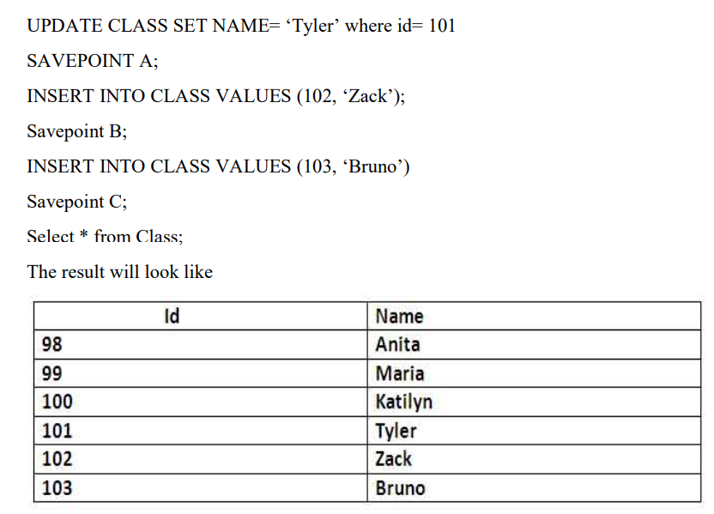
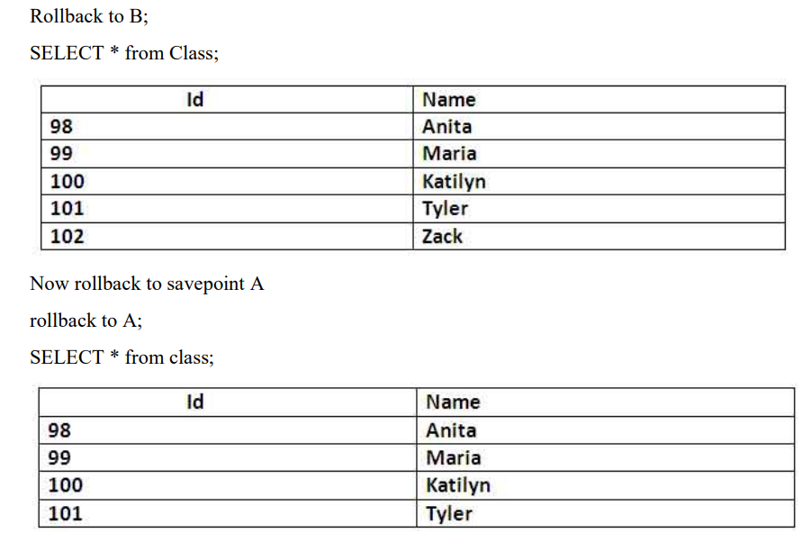

5.3 Concurrency control
5.3.1 Concurrency control Algorithms
5.3.1 Locking commands
a. Row-Level Locking – SELECT ... FOR UPDATE
b. Table-Level Locking – LOCK TABLE
Lock Modes
Lock Mode | Description
ROW SHARE | Allows concurrent access; prevents other sessions from locking the table exclusively.
ROW EXCLUSIVE | Prevents other sessions from locking in share mode. Used by default for DML.
SHARE | Allows queries but not updates or deletes.
SHARE ROW EXCLUSIVE | A mix; more restrictive than SHARE.
EXCLUSIVE | Prevents all other access — full table lock.

c. COMMIT – Release All Locks
d. ROLLBACK – Undo Changes & Release Locks
5.3.2 Example (1 example for your project)

CHAPTER 6
FRONT-END AND BACK-END CODE OF <PROJECT TITLE>

6.1 Front–End Module codes
6.2 Database connectivity

CHAPTER 7
RESULTS AND DISCUSSIONS

7.1 Screenshots of front-end

7.2 Screenshots of Database

References

